Amberley Primary School
Our Safeguarding Children Team

Designated Safeguarding
Deputy

Name: Miss Low
Title: Support staff Y6

Designated Safeguarding
Deputy

Name: Mrs Blackett
Title: SLT / English lead

Add photo here
Designated Safeguarding
Lead

Name: Mr Dawson
Title: SENco / SLT

Add photo here
Designated Safeguarding
Deputy

Name: Mrs Hurst
Title: SEMH lead




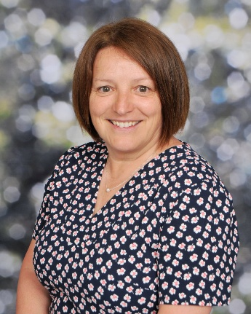


Our Safeguarding Children Process

If you are concerned

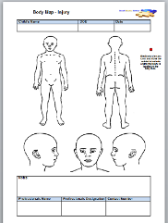
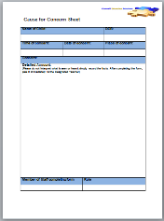
I have a safeguarding concern relating to a child, parent or member of staff

1
Write down your concern on a cause for concern sheet
2
NSPCC
Tel: 0808 800 5000

Police
Tel: 101 (non emergency)
Tel: 999 (emergency)

Children’s Social Care
Tel: 0345 2000 109

Where appropriate the Designated Safeguarding Lead will give feedback. In some incidences the case details may be confidential

Designated Safeguarding Lead

Name: Mr Dawson
Title: SENco / SLT

Add photo here

Designated Safeguarding Deputy

Name: Mrs Hurst
Title: SEMH lead

Add photo here

Designated Safeguarding Deputy

Name: Mrs Blackett
Title: English lead / SLT

d photo here

Designated Safeguarding Deputy

Name: Miss Low
Title: Year 6 support staff

Add photo here

Inform a member of the Safeguarding Team
3
Other useful contacts:

Feedback to the referrer
6
Advice will be given on the next steps
4
A plan will be put in place
5
This may or may not involve a referral to Social Care

This may or may not involve actions to be taken by the referrer

