
Amberley Primary School Homework Policy- September 2026
Rationale
At Amberley Primary School we believe that homework is an essential part of pupils’ learning. In line with National Curriculum requirements, homework is set and children are encouraged to, and expected to establish good homework habits from the beginning of their school life. Homework is set regularly as a means of reinforcing and extending learning.

Expectations
Homework should not be an onerous task but should be easily understood by the children and based on the learning they have completed in class time. Homework will be set using a similar format in each year group to ensure that expectations are clearly communicated. The formats are used:

Key Stage 1

In Y1 and Y2, a homework ‘menu’, knowledge organiser and spelling list will be uploaded to Seesaw and sent home as a hard copy at the beginning of each half term.

Weekly, children should:
- Read at home- a reading scheme book and a reading for pleasure book will be provided and the reading record should be completed by an adult.
- Practice spellings- Each week a spelling list will be uploaded to spelling shed where the children can practice the spellings of the week. Login information is recorded inside of the homework book provided.
- Select an activity from the homework menu to complete. Each half term a homework menu will be provided that includes tasks from across the curriculum that link to what the children are learning in school. One task should be completed each week. Homework books will be provided for children to complete the work in. These books do not need to be returned to school, a picture of the children’s work can be uploaded to seesaw for class teachers to see.

Below shows the template that will be shared with parents:
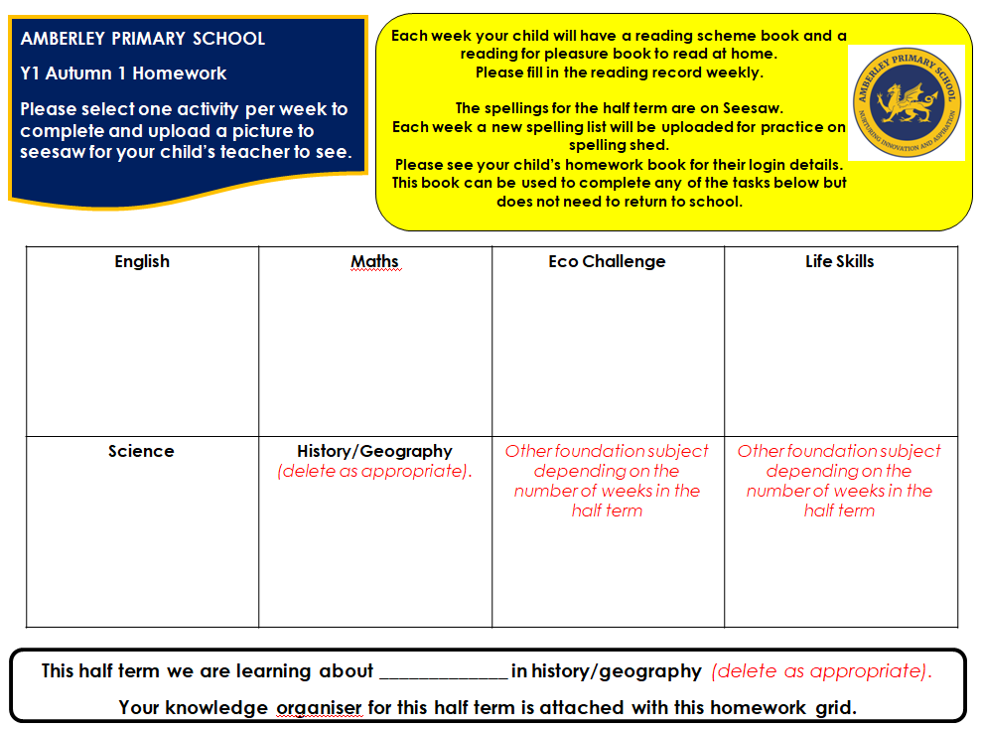

Lower Key Stage 2

In Y3 and Y4, a homework ‘menu’, knowledge organiser and spelling list will be uploaded to Seesaw and sent home as a hard copy at the beginning of each half term.

Weekly, children should:
- Read at home- a reading book will be provided and the reading record should be completed by an adult.
- Practice spellings- Each week a spelling list will be uploaded to spelling shed where the children can practice the spellings of the week. Login information is recorded inside of the homework book provided.
- Practice timestables- Each week children should practice their timestables using the website/app ‘Timestable Rockstars’. Login information is recorded inside of the homework book provided. Hard copy practice sheets can be provided if necessary.
- Select an activity from the homework menu to complete. Each half term a homework menu will be provided that includes tasks from across the curriculum that link to what the children are learning in school. One task should be completed each week. Homework books will be provided for children to complete the work in. These books do not need to be returned to school, a picture of the children’s work can be uploaded to seesaw for class teachers to see.

Below shows the template that will be shared with parents:
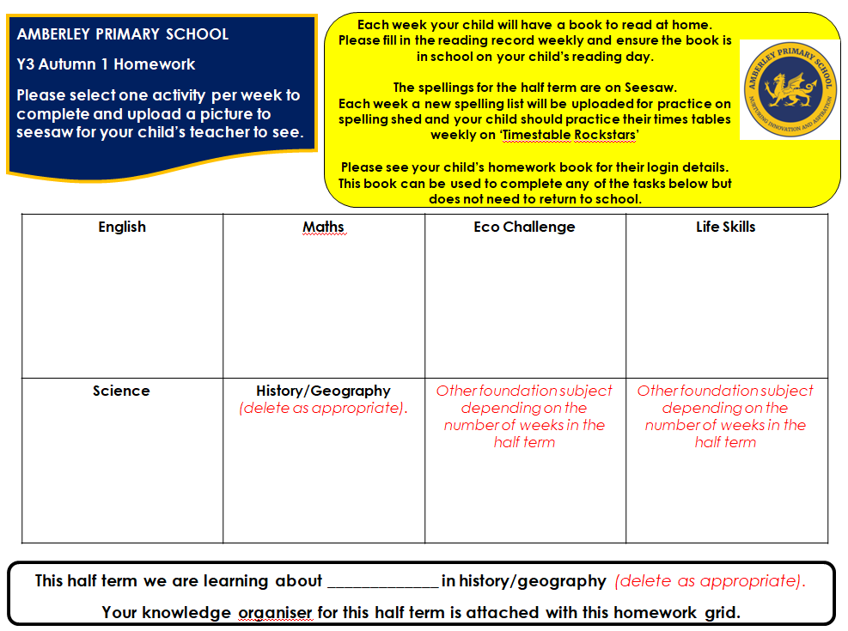

Upper Key Stage 2

In Y5 and Y6, a knowledge organiser and spelling list will be uploaded to Seesaw and sent home as a hard copy at the beginning of each half term. A homework menu will not be used in Y5 and Y6. Instead, more formal maths and English tasks will be set weekly for the children to complete in preparation for more formal homework that is set at High School.

Weekly, children should:
- Read at home- a reading book will be provided and the reading record should be completed by an adult.
- Practice spellings- Each week a spelling list will be uploaded to spelling shed where the children can practice the spellings of the week. Login information is recorded inside of the homework book provided.
- Practice timestables- Each week children should practice their timestables using the website/app ‘Timestable Rockstars’. Login information is recorded inside of the homework book provided. Hard copy practice sheets can be provided if necessary.
- Complete both the maths and english tasks provided. These tasks will be opportunities to practice skills that the children have learned in class. Homework books will be provided for children to complete the work in. These books do not need to be returned to school, a picture of the children’s work can be uploaded to seesaw for class teachers to see. These tasks will be uploaded every Friday to Seesaw and should be completed by the following Wednesday.

Below shows the template that will be shared with parents:
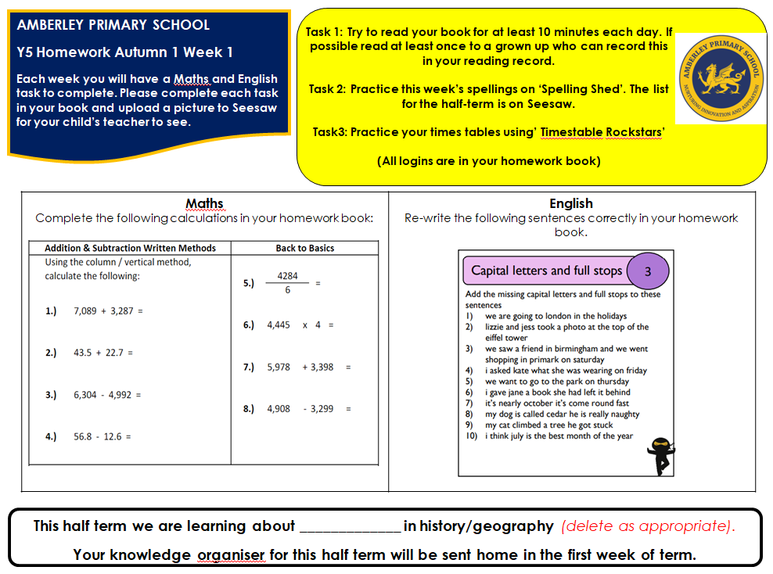

Homework should be adapted for children with additional needs where necessary.

Homework completion should be encouraged and promoted and excellent homework will be celebrated regularly in assemblies. It is however, an optional extra, and children should not be expected to complete missing homework in class time.

